


David Shamlin
SIMON’s GUIDE to success
Contents
INTRODUCTION 2
HOME SCREEN 3
TEAM SAVINGS LANGUAGE (INITIATIVE STATUS) 3
WORK PLAN MANAGEMENT SCREEN 4
CREATE NEW INITIATIVE 5
Initiative Main / Home Screen 5
Initiative Field Definitions & Uses 5
Action Buttons 7
Member Baselines 8
Member Savings 9
Frequently Asked Questions 13
OTHER FUNCTIONS 18
Vendor Management 18
Category Management 18
Contract Management “Connie” 18
Rebate Management 18
REPORTS 18
All Reports 18
Work Plan Report 18
Contract Report 18
Validation Report 18
OTHER TOOLS 18
Simon Roadmap 18
Connie Roadmap 18

INTRODUCTION

SIMON is primarily TPC’s Source of Truth for reporting on TPC Work Plan. TPC Leadership, Finance, Account Management, & Growth team members rely on Initiative Owners input and updates to Simon related to the initiatives Planned, In Process, or Completed in the Work Plan in order to:
- Update Member Financials & Create Member Statements
- Establish & Track Progress towards Annual & Quarterly Goals
- Maintain awareness of & Provide Guidance on Work Plan Activities
- Work with Member Stakeholders during Member Visits and other Meetings
- Communicate the value of being a TPC Member to prospective Members

The following is an overview of SIMON Work Plan Management screens and data fields.

Simon is one the family of tools internally developed and actively used in managing various aspects of TPC business. Others include Lucy (Financial Management & Reporting), Connie (TPC Contracts Management & Reporting), and Sally (Savings Realization Application). As new family members are added to the toolkit, a birth announcement will be sent!

This Simon Guide is current as of April 9, 2019 and will be updated as material changes to the application are made.

HOME SCREEN
- Summary of Work Plan Savings by Year and Work Group
  - Filter for TPC, Sourcing, Purchased Services, Revenue Cycle, or Supply Chain
- Updated Real-Time
- Includes Actual “Completed- Audited” and Projected Savings as well as a “Forecast” based on “Confidence Factor”
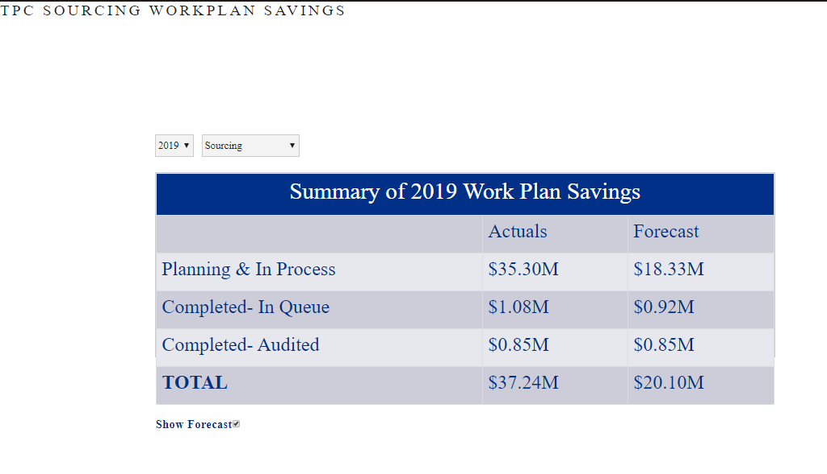

TEAM SAVINGS LANGUAGE (INITIATIVE STATUS)
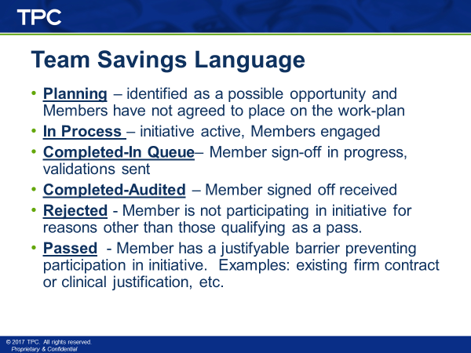

WORK PLAN MANAGEMENT SCREEN
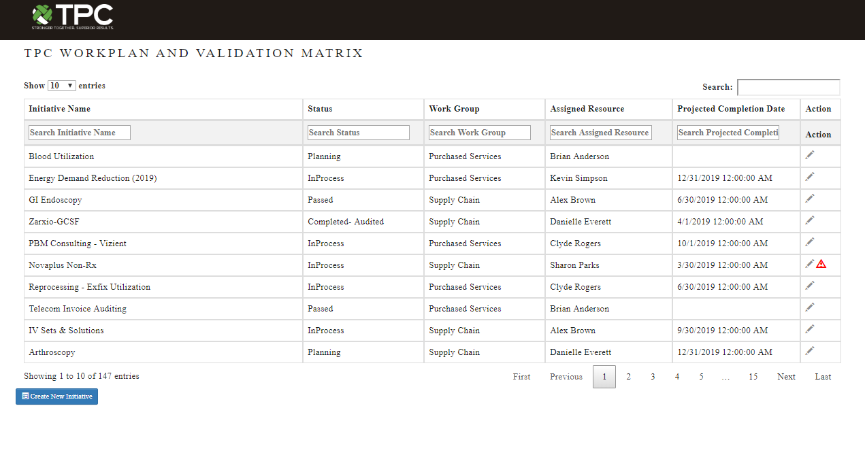
- Create new and edit existing initiatives
- Summary list of initiatives. Can set “Show” to 10, 25, 50, or 100 initiatives on screen at one time.
  - Visible / Searchable Fields:
    - Initiative Name
    - Status (Initiative and not Member Status)
    - Work Group
    - Assigned Resource
    - Projected Completion Date
    - Action (Edit/Action Flag)

CREATE NEW INITIATIVE
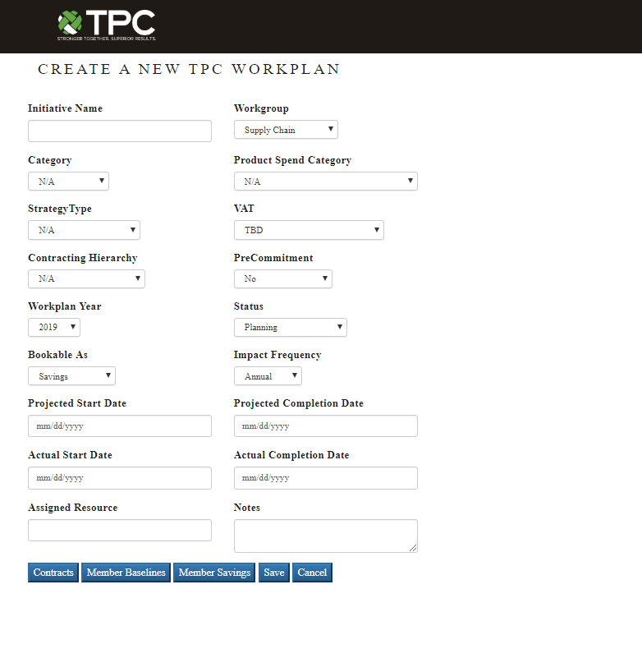

Initiative Main / Home Screen

Initiative Field Definitions & Uses
- Initiative Name – This will be the official name of the initiative. It is important that all documentation consistently use this name for the initiative to avoid Member confusion.
- Workgroup – Which TPC work group owns the initiative? Purchase Services, Revenue Cycle, Supply Chain
- Category – This field allows finance and analytics to continue a practice of trending savings across prime spend categories. These categories are: Capital, Commodity, Pharmacy, PPI, & Service. Additional categories have been added to this field and may be eliminated to reduce confusion.
- Product Spend Category – This dropdown list contains previously used commodity or service level categories that enables TPC to report more granular detail of the categories of spend included on the work plan. New categories can be added by the dictionary owner.
- Strategy Type – This field is to identify the strategy to be employed for the initiative.
  - Utilization – Also interchangeable with the term Performance Improvement, this is a strategy involving, as a primary component, changes in operational performance resulting in a decrease in costs, increases in revenue, or a combination of both.
  - Pricing (contracting) – Strategy is used when negotiating pricing enhancement with a vendor or when placing a category out to bid. Do not use for tier slotting.
  - Implementation – Strategy is used when implementing or on-boarding a new Member to TPC
  - Tier Slotting – Status used when strategy is tier leveling is used.
  - GPO Transition – Also known as GPO Implementation. These are initiatives related to TPC implementing a new GPO relationship. Implementation period savings are tagged with this status as the GPO master contract may have implementation period performance terms that will require solid documentation of implementation outcomes versus projections.
  - Rebates – Status used strictly for documenting rebates only.
- VAT – Select the Value Analysis Team or other Committee from the dropdown that is the core group working the initiative. Included in the dropdown are: Cardiology/DI, Laboratory, Medical/WC, Perioperative, Pharmacy, Council, CSC, ESC, IT Committee, HR, Revenue Cycle, Support Services
- Contracting Hierarchy – TPC must consider contracting in the following order:
  - GPO: Existing GPO Base / Tiered Agreement
  - GPO Tier Enhancement: Enhanced Tier to GPO Base Agreement
  - TPC Led by GPO: TPC Custom Agreement
  - TPC: TPC Custom Agreement; No GPO support
- PreCommitment – This flag has been added to allow for easy identification of initiatives that are either confirmed “PreCommit” or “PreCommitTarget” status. Default is “No.”
  - PreCommit: flag is set only after the “Commitment Vote” or signed Member letters have been received and there is enough participation to proceed.
  - PreCommitTarget: flag is set to designate planned initiatives that appear to qualify as a PreCommit; however, a Commitment Vote has not yet taken place.
- Work Plan Year – defaults as current year. However, initiative owners may begin to stage future year initiatives based on contract end dates and other activities.
- Status – This is the overall initiative status and follows Team Savings Language. Please note, updating this field does not automatically update the Member Level Status field, found in the Member Savings Screen. Member Level Status Field Must be updated in order to accurately reflect each Member’s standing in an initiative.
  - Planning – identified as a possible opportunity and Members have not agreed to place on the work-plan
  - InProcess – initiative active, Members engaged
  - Completed- In Queue – Member sign-off in progress, validations sent
  - Completed- Audited – Member signed off received
  - Passed – Member has a justifiable barrier preventing participation in initiative. Examples: existing firm contract or clinical justification, etc.
  - Rejected – Member is not participating in initiative for reasons other than those qualifying as a pass.
- Bookable As – Allows classification of the financial value of the initiative into one of three categories:
  - Savings – Value is attributable to a lowering of Member costs as calculated using the approved Baseline and applying the new product or savings costs (and/or rebates) and taking the difference between the before and after value.
  - PI – Value is attributable to decrease in or elimination of operational costs or in recovery of revenues through identification of performance Improvement efforts
  - Non-Bookable – Value is not bookable to the TPC goal. AN example of non-bookable value is a Rebate received which is already part of the first-year savings sign-off or any rebate in years 2 through end of contract.
- Impact Frequency – Newly added field intended to eliminate repetitive keystrokes for work plan entries that recur over timed periods. Examples of entries with this characteristic are incentive and rebate entries. Setting the flag to “Annual”, “Quarterly”, or “Monthly” will create the recurrence for the initiative owner.
- Projected Start Date – Please use this field when setting up a new initiative to project when the initiative should move from the “Planning” to “InProcess” status. This allows Simon to help identify initiatives that are anticipated to be active by a certain date to meet timing to have completed the initiative prior to the end of existing contracts in the category.
- Actual Start Date – Updating this field with the actual start (InProcess) date turns off the alert function triggered by surpassing the “Projected Start Date” and is also beneficial in helping TPC become more efficient in managing initiatives as well as Member expectations related to timing of initiatives.
- Actual Completion Date – Similar to the “Actual Start Date,” as the initiative changes status from “InProcess” to “Completed- In Queue” this field should be updated with the current date. There are both tactical and strategic reasons for completing the Projected and Actual date fields.
  - Tactical – Allows for current work plan year reporting. Also provides for a cut-off point for savings attributable in one work plan year versus the next. If an initiative enters Completed- In Queue before the current work plan year ends, savings is typically attributable to the ending work plan year.
  - Strategic – Over time, consistently completing timing fields will enable TPC to become more efficient in work plan management and will also be able to better allocate resources needed to manage the plan.
- Assigned Resource – This field is also the “Initiative Owner.” Among other reasons, completion of this field will allow for easy identification of the TPC lead for each initiative and work plan entry.
- Notes – This is a freeform field that allows the initiative owner to keep a brief record of activities, key facts, current progress, etc within the work plan record.
*Hint: Click in the bottom right corner of the Notes box to expand it and see all your notes at one time.
Action Buttons -

Contracts – Links to the TPC Contracts module, “Connie”.
- As contracts are created that link to an initiative, users can enter the “Initiative Name” into the appropriate field of the Contract entry screen.
- Contracts linked to an initiative will be listed in future occurrences of user clicking on the “Contracts” button within the Initiative window.

Member Baselines –
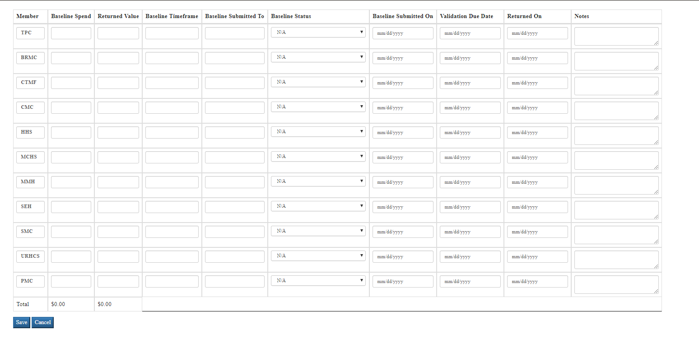
- Member – Each TPC Member is separately listed for entering Member specific Baseline information. There is also a TPC entry. If Member values are known, enter these values. If early in the planning stage and Member level details are not known yet, an aggregate value for TPC should be entered. Be careful not to enter a TPC value as well as Member detail as this will create an error in values.
- Baseline Spend – Use this field to enter the initial/unvalidated Member Baseline Spend. Unvalidated Baseline Spend is spend that has been pulled but not yet reviewed and approved by Member representatives.
- Returned Value – Also known as Validated Baseline Spend. This is the Baseline Spend that results from the Member’s review of the unvalidated spend file. The value may equal or differ from the unvalidated spend total. However, the initiative owner should understand the reason for any differences and work with Member to come to an agreement (Reconciliation) on final Baseline value as savings projections for the initiative will be calculated from this total.
- Baseline Timeframe – Typically TPC baselines from the most recent and complete 12 months spend available for our Members. The baseline date range is entered here in the form MM/DD/YYYY – MM/DD/YYYY.
  - There may be occasions where an alternative baseline period may be suggested, necessary, or requested by Members. These will be determined on a case-by-case basis and should be documented with the reason for the deviation from typical. (See notes field)
- Baseline Submitted To – This is the Member representative that is expected to review/approve the Baseline file.
- Baseline Status – This status field allows the Initiative owner to track and understand what the current standing of the Baseline is. Status’ include:
  - N/A: Not Applicable / Baseline not yet sent or Member not participating in initiative
  - Pending Member Return: validation request has been made of the Member. Member response not yet received
  - Member Returned – In Reconciliation: Member has returned the validation with changes which Initiative Owner will need to review and work with Member to align on value.
  - Member Returned – Completed: Member and Initiative Owner in agreement on Baseline Spend
  - Included in Savings Validation: use to identify occurrences where Baseline and Savings validation occur at the same time in the same file.
- Baseline Submitted On: Enter the date the validation file and request to validate was sent to the Member reviewer.
- Validation Due Date: This is 10 business days from the date the validation request was submitted to the Member reviewer.
- Returned On: This is the actual date the validation was returned /approved by the Member reviewer.
- Notes:Freeform notes field for entering comments related to the Baseline Validation by Member.
- Save: Saves user’s changes and returns user to the Work Plan main screen.
- Cancel: Discards any changes made on the current screen and returns user to the Work Plan main screen.

Member Savings – Use this screen to document Member Savings information. Information includes Bookable Status, Member, Projected Impact, Completed Audited Impact, Sign-Off Status, Billable Amount, Sign-Off Date, Notes, & Confidence Factor
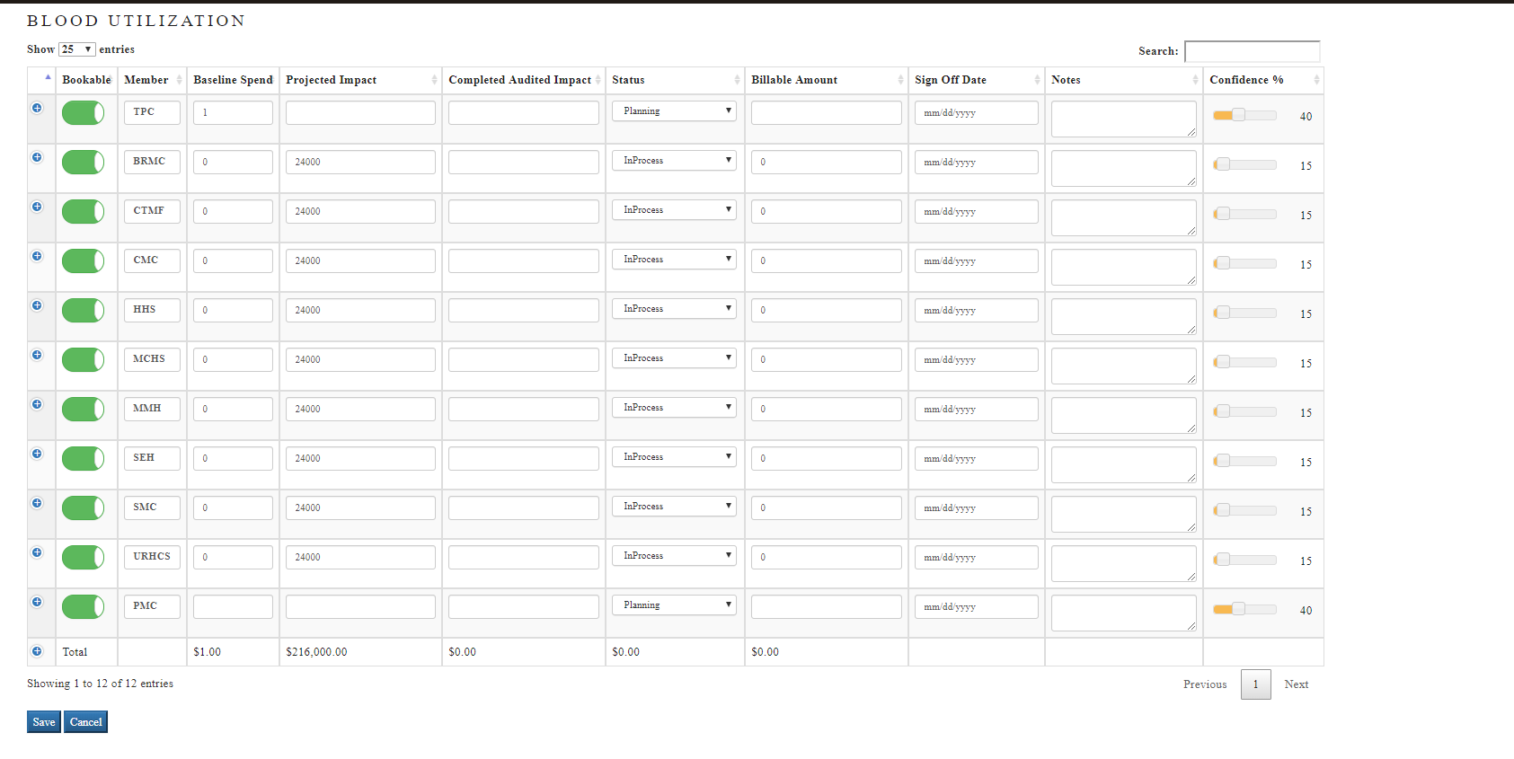
- “+” Expand Button – during the sign-off phase of an initiative, it is necessary to fill-in the sign-off support information located on the sub-screen of the Savings screen accessible by clicking the “+” icon on the left hand side of the Member entry (see below screenshot).
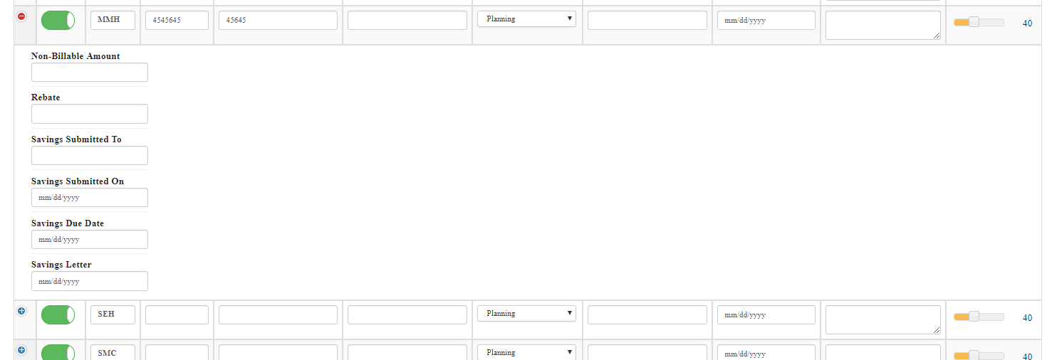

- Non-Billable Amount – if any portion of the savings sign-off will not be billed to the Member, enter that amount here.
- Rebate – if any portion of the savings sign-off is attributable to Rebates, enter that amount here.
- Savings Submitted To – Enter the name of the primary recipient/reviewer of the validation here.
- Savings Submitted On – Enter the date the validation request was sent out to the Member.
- Savings Due Date – Enter the date the validation is due back from Member. TPC process is for a 10 business day turn time for Member to complete and return Savings Validations.
- Savings Letter – Do not update. This field updated during reconciliation of Vizient Periodic Savings Letter by Operations.
- “Bookable” flag – By default, this flag should be set to ON (green). This flag indicates whether the individual Member sign-off value should be counted as part of the TPC SAVINGS & PI goal for the calendar year. If ON, yes, the values is included. If off, the value is excluded.
*If unclear whether values are considered bookable or non-bookable, seek your manager’s advice.
- Member – Each TPC Member is separately listed for entering Member specific Savings information. There is also a TPC entry. If Member values are known, enter these values. If early in the planning stage and Member level details are not known yet, an aggregate value for TPC should be entered. Be careful not to enter a TPC value as well as Member detail as this will create an error in values.
- Baseline Spend – Member’s approved baseline spend. Does not currently carry forward from “Baseline” screen.
- Projected Impact – Enter the Member’s projected impact. This may be available early in the initiative and may be later adjusted as the initiative progresses. As updates in the value occur, this field should be reviewed periodically and adjusted for material changes.
- Completed Audited Impact – This is the value the Member has signed-off on.
- Status –This is the Member level status and is adjusted separately from the Initiative Status. Status flags definitions are the same as Initiative Status.
  - Planning: identified as a possible opportunity and Members have not agreed to place on the work-plan.
  - InProcess: initiative active, Members engaged
  - Completed- In Queue: Member sign-off in progress, validations sent
  - Completed- Audited: Member signed off received
  - Passed: Member has a justifiable barrier preventing participation in initiative. Examples: existing firm contract or clinical justification, etc.
  - Rejected: Member is not participating in initiative for reasons other than those qualifying as a pass.
- Billable Amount – By default, and in addition to being “Bookable,” Member Savings is considered “Billable”; meaning TPC and/or Vizient’s share of the Sign-Off value will be billed to the Member. However, there are occasions where Members should not be billed for a portion, or possibly none, of the savings. These occurrences may include, but are not limited to Rebates, Incentives, & portions of savings that are to be recognized as occurring in connection with the initiative however, neither TPC nor Vizient are to be compensated (an example are Pharmacy Name Brand to Generic Conversions. In these cases, while the opportunity to convert is being worked on as a Network, most TPC Members will convert from Name Brand to Generics as they become available. We document full savings in Work Plan, but bill only for the value TPC or Vizient contribute to the Savings…negotiated discount pricing off of the cost of the generic, for example.)
- Sign Off Date – Record the date the Member returned/approved the Savings Validation.
*The savings validation is not considered Signed-Off until both the Member and TPC agree on sign-off value.

- Notes – This is a freeform field that allows the initiative owner to keep a brief record of activities, key facts, current progress, etc within the work plan record.
*Hint: Click in the bottom right corner of the Notes box to expand it and see all your notes at one time.

- Confidence % - The Confidence Factor adjustment slide aids Finance in forecasting Work Plan values on an initiative level. By default, Confidence Factors increase as initiative status changes from Planning (40%) to InProcess (60%), Completed- In Queue (80%), & Completed- Audited (100%) status. However, as an Initiative Owner, you can customize the confidence factor, by Member, by moving the slide bar to the appropriate factor (%) in consideration of Member feedback or other factors.
*Confidence Factor for Passed or Rejected status is always 0%

- SAVE – Saves user’s changes and returns user to the Work Plan main screen.
- CANCEL – Discards any changes made on the current screen and returns user to the Work Plan main screen.
- PREVIOUS/NEXT – Click to move from one page of values to the next or back to the previous page of values. When multiple pages exist, you may also click on a page number as shown.
- SHOW # ENTRIES – By default, this page will only show the top 25 Member entries. As more TPC Members are added, the user may select to show 10, 25, 50, or 100 Member entries on the initial screen.
- SEARCH – Currently no a useful function for this screen as all Members will appear on the first Savings screen. As TPC expands beyond 25 Members, you may use this search box to find/filter for an individual Member entry.

Frequently Asked Questions

Find your question below and ctrl-click on it to jump to the answer you seek. After viewing the answer, click on Mr. Smiles to return to this list.
- What is Simon?
- What is Simon not?
- What type of Work Plan activities should I document in Simon?
- When do I add an initiative to Simon?
- What is the minimum information I need to create a new initiative?
- How important is it that an initiative name remain consistent for the duration of the initiative and on all initiative related documentation?
- If I created an initiative in error, created a duplicate entry, or added an initiative that is not moving forward, how can I remove it from the work plan?
- Do I add 1st year rebates to the work plan?
- Are 1st year rebates Bookable? Are they Billable?
- How do I create initiatives that have multiple components, i.e. a wraparound initiative containing multiple categories of products which may stand on their own as separate initiatives?
- I am working jointly on an initiative with a co-worker. Should I put both of our names as the Assigned Resource (Initiative Owner)?
- Vizient is leading an initiative. Shouldn’t I put their name in the Assigned Resource field?
- What is the difference between the Overall Initiative Status, Member Status, & Baseline Status and di I need to manage each of these status entries?
- What is the difference between PASSED and REJECTED status? When are they used?
- When do I change initiative status from Planning to InProcess?
- When do I change initiative status from InProcess to Completed- In Queue?
- When do I change initiative status from Completed- In Queue to Completed- Audited?
- Who do I forward ideas on improving Simon to?
- I think there is a bug in Simon. Who do I report this to?
- I have requested a change to Simon, when should I expect the change to be implemented?

- What is Simon?
Simon is TPC’s proprietary work plan reporting and management application. The primary purpose of Simon is to be the TPC Source of Truth related to TPC work plan initiatives & the savings and PI value TPC presents to and obtains Member sign-off during any given work plan year. Prior to introducing Simon to TPC in late 2018, TPC’s work plan was managed in a decentralized fashion through separate databases and required considerable manual work.

- What is Simon NOT?
In its current form, Simon is not a comprehensive initiative activities management tool. While Simon does serve as the work plan reporting hub, it should be viewed more as an initiative pipeline and financial information database than a historical record of all the tactical initiative details.

- What type of Work Plan activities should I document in Simon?
Initiatives and Rebates are the only activities that are entered into Simon. Admin Fees are reported through other Finance department tools at this time.

- When do I add an initiative to Simon?
An initiative should be added to Simon at the point in time it is identified as a potential opportunity that will be brought to the appropriate Member stakeholder group. It should be onboarded to Simon under “Planning” status. The Initiative Owner does not need to wait until fully vetting out the initiative and may stage the initiative with minimally available information.
-Note: In order to reflect an initiative on the Work Plan Report, the Initiative Owner must open an entry, at a minimum, for “TPC” and with a value of $1 Baseline in the “SAVINGS” Screen.

- What is the minimum information I need to create a new initiative?
At a minimum, the Initiative Owner must know the Initiative Name*, Workgroup, VAT, Category, Product Spend Category, and Projected Start Date. In addition to this information, Initiative Owner must enter a value in the “TPC Baseline,” in the “SAVINGS” screen, as this will add the initiative to report outputs.

- How important is it that an initiative name remain consistent for the duration of the initiative and on all initiative related documentation?
Once an initiative name is selected, it is critical that the initiative name remain as first published to the work plan. The prime reason for this is to avoid creating confusion for Members. In addition, changing names on initiatives may also create a disconnect between the financial records of TPC, Vizient, and Members. Overall, it presents a challenge keeping information organized.

- If I created an initiative in error, created a duplicate entry, or added an initiative that is not moving forward, how can I remove it from the work plan?
Currently, there is not a DELETE function available to any user of Simon. If you create an unnecessary entry in Simon, Initiative Owners are asked to update the Initiative Name by preceding it with “Delete – “ to identify entries to be deleted. This will enable Data & Technology to remove the entry in the background.

- Do I add 1st year rebates to the work plan?
Yes, rebates, regardless of what period they are attributable for need to be entered into Simon.

- Are 1st year rebates Bookable? Are they Billable?
There is a difference between first year rebates and rebates attributable to contract year periods beyond year one. The difference is that year 1 rebates are neither Bookable nor Billable and subsequent years are Bookable but non-billable. The reason first year rebates are non-bookable is due to the rebate projection being part of the booked savings sign-off.

- How do I create initiatives that have multiple components, i.e. a wraparound initiative containing multiple categories of products which may stand on their own as separate initiatives?
As a best practice, to identify multiple initiatives that will have distinctly recordable values by Member but roll up to a Master or Wraparound Initiative, follow the Initiative Name with a dash and a tag to easily identify each as part of the group.

- I am working jointly on an initiative with a co-worker. Should I put both of our names as the Assigned Resource (Initiative Owner)?
No. While there may be more than one TPC employee working on an initiative, YAY TEAMWORK!, there needs to be a primarily accountable person. This person needs to be listed as the Assigned Resource (Initiative Owner).

- Vizient is leading an initiative. Shouldn’t I put their name in the Assigned Resource field?
No. While our valued partners and Vizient team members are actively engaged in, or providing Subject Matter Expertise for any number of our initiatives, the Initiative Owner for all initiatives will be recorded as a TPC employee. This is specifically useful from an accountability and resource planning perspective.

- What is the difference between the Overall Initiative Status, Member Status, & Baseline Status and di I need to manage each of these status entries?
The overall Initiative Status provides a current status of the progress of the initiative. It should be noted as the earliest initiative stage that any Member is currently slotted to. The Member Status, found in the Savings screen, is to identify which stage of the initiative individual Members are in. Typically, Members status remains aligned during the Planning and InProcess stages of an initiative and to the point of entering the Completed- In Queue stage. It is usually after the request for savings validation where Member status may differ until all Members are in Completed- Audited.
* Some Members may PASS or REJECT initiative opportunities. This may also create a disparity in status. However, unless all Members reject or pass, Initiative Status should never reflect these status.
- What is the difference between PASSED and REJECTED status? When are they used?
PASS: Members are given a status of PASS for an initiative when there are circumstances particular to them that prevent them from participating in an initiative. These include, but are not necessarily limited to, being contracted for the category of spend the initiative involves and unable to early terminate the existing contract; the initiative would require the Member to expend unreasonable up-front capital expense, Member and supplier history (case-by-case), Member does not utilize the products or services that are the subject matter of the initiative.

REJECT: Members are considered to have rejected the opportunity based on preference or a lack of circumstances supporting a PASS.

The status of a Member’s participation in an initiative can be updated to PASS or REJECT at any time. As such, it may not always be possible to document the projected TTV the Member Passed on or Rejected. Since the amount of Passed or Rejected TTV can add up to considerable dollars each year, TPC has tried to track this historically.

- When do I change initiative status from Planning to InProcess?
An initiative status moves from Planning to InProcess at the point the initiative has been presented to the primary stakeholder group and there is enough mass and agreement to actively engage. “3 or More”

- When do I change initiative status from InProcess to Completed- In Queue?
An initiative is placed in the Completed- In Queue status when Members are notified of a Savings Validation available for their review and return. All participating Members are to be moved to Completed- Audited on the same date.

- When do I change initiative status from Completed- In Queue to Completed- Audited?
An initiative status is updated to Completed- Audited only after ALL Members (those not placed in PASSED or REJECTED status) have returned their Savings Validations and all parties, Member, TPC, & Vizient agree the validation of savings is complete and sign-off value is not in dispute.

- Who do I forward ideas on improving Simon to?
Director of Supply Chain Operations

- I think there is a bug in Simon. Who do I report this to?
Director of Supply Chain Operations

- I have requested a change to Simon, when should I expect the change to be implemented?
All non-critical/non-high priority requests are work planned by the Director of Data & Technology. As such, non-urgent requests will be worked into a schedule of application updates. The lower the priority, and more difficult the level of programming related to an ask, the longer the programming timing.

For Critical/High Priority changes and debugging, a negotiated resolution date will be provided to the originating requestor and to all affected users of the application.

OTHER FUNCTIONS

Vendor Management – Current Dictionary Owner: David Shamlin
Category Management – Current Dictionary Owner: David Shamlin
Contract Management “Connie” – Contract Management and Official Record of TPC Contracts
Rebate Management - Current Dictionary Owner: Larisa Sadovsky

REPORTS
All Reports – On a permissions basis, this link accesses TPC reports in the “Lucy” module.
Work Plan Report – User accessible on-screen or downloadable report of the work plan
Contract Report – User accessible on-screen or downloadable report of TPC contracts
Validation Report – User accessible on-screen or downloadable report of work plan validations

OTHER TOOLS
Simon Roadmap – Enhancement / Debug request tracker to prioritize activities related to managing Simon updates.
- Users should report bugs and make enhancement requests through David Shamlin
- David and Roopa discuss and agree on priority of request
Connie Roadmap – Enhancement / Debug request tracker to prioritize activities related to managing Connie updates.
- Users should report bugs and make enhancement requests through David Shamlin
- David and Roopa discuss and agree on priority of request

